Module 1: Entrepreneur & Entrepreneurship
Structure of the Unit
- Who is an Entrepreneur?
- Types of Entrepreneur (Ex. VLE)
- Characteristics of Entrepreneur
- Major mistakes Entrepreneurs Make
- What is Entrepreneurship?
- Factors that influence Entrepreneurship
- Social Entrepreneurship-Concept and Importance
- Risk taking-Concept; types of business risks
- Identification of Right Business Opportunity
- Women Entrepreneurship
- Work Life Balance

Who is an Entrepreneur: An Entrepreneur is an individual who, rather than working as an employee, runs a small business and assumes all the risks & rewards of a given business venture, idea, or goods or service offered for sale. The Entrepreneur is commonly seen as a business leader and innovator of new ideas and business processes. Entrepreneurs are commonly seen as shouldering individual risk, organising a business process, setting up a venture and profiting from the venture.

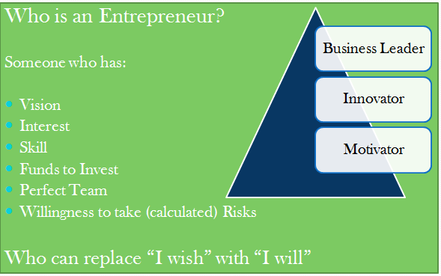

Types of Entrepreneurs
- Business Entrepreneurs: Business entrepreneurs are individuals who conceive an idea for a new product or service and then create a business to materialize their idea into reality. They tap both production and marketingresources in their search to develop a new business opportunity.
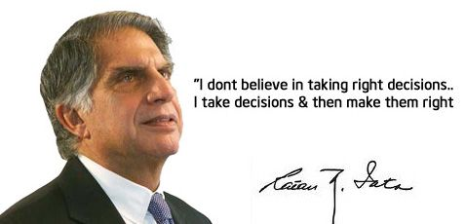

- Trading Entrepreneurs: Trading entrepreneurs are those who undertake trading activities and are not concerned with the manufacturing work. They identify potential markets, stimulate demand for a product line and createa desire and interest among buyers to go in for that product.
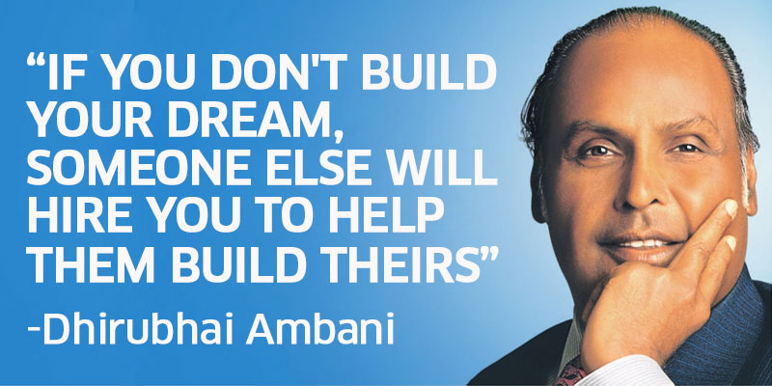

- Industrial Entrepreneurs: Industrial entrepreneurs are essentially manufacturers, who identify the potential needs of customers and tailor a product or service to meet the marketneeds. They are product oriented and start an industrial unit because of the possibility of making some new product.
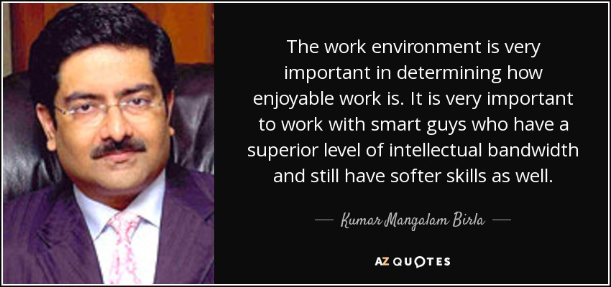

- Corporate Entrepreneurs: Corporate entrepreneursare those who demonstratetheir innovative skills in organizing and managing corporate undertaking. A corporate undertaking is a form of business organization, which is registered under some Statute or Act, which gives it a separate legal entity.
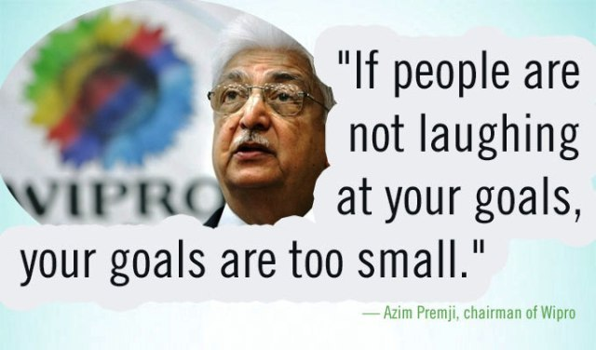

- Agricultural Entrepreneurs: Agricultural entrepreneurs are those who undertake agricultural activities such as cultivation and marketing of crops, fertilisers and other agricultural inputs.

Rajiv Bittu, a part-time Chartered Accountant and a full-time farmer, took up farming to change his daughter’s views about farmers. He took land on lease in Kuchu village, 32 km away from Ranchi. As he did not have the funds to pay rent for the land, he offered the landlord 1/3rd of the produce he grew. He made use of the latest technology, like drip irrigation and mulching, to get maximum yield on his farm. Now, he claims that he earns more from farming than his accountancy firm!
Village-Level Entrepreneur: Village-level entrepreneurs are change agents who are accelerating the scope of Digital India services across the villages in India through Common Services Centers (CSC). VLEs provide a number of services at the grass-root level through the CSCs. This includes various Government and public utility services, viz. Passport, PAN Card, National Pension Scheme, Election services, etc. Apart from the government services, CSCs also deliver various financial services, education and skill development services, healthcare and agriculture services.
A network of 3 lakh VLEs, of which 2.10 lakh are in Gram Panchayats, are actively providing various online public utility and financial services to citizens, quality healthcare, apart from boosting entrepreneurship and employment in villages and smaller towns across the country.
The VLE, with his/her strong entrepreneurial capability, sustains the CSC scheme. A good VLE has strong entrepreneurial traits and social commitment, apart from financial stability and also commands credibility and respect in the community.
Qualification required for a VLE
a) The VLE should have a valid Aadhaar number.
b) Should be a village youth above 18 years of age.
c) Must have passed the 10th level examination from a recognized board as minimum level of educational qualification.
d) Should be fluent in reading and writing the local language and should also have basic level knowledge of English language.
e) Prior knowledge in basic computer skills would be a preferred advantage.
f) The VLE should be motivated enough to be a prime driver of social change and disperse his/her duties with utmost dedication and honesty.
Around 10 lakh people are employed as at CSCs across the nations, including VLES, faculty members, data entry operators etc. Village-level entrepreneurs are the backbone of the CSC. They are the first respondents of the governance and they havethe power to transform the nation by empowering villagers and creating employment opportunities in rural India.
CSC is also an umbrella for more than 50,000 women entrepreneurs, which is one of the largest networks in the country. The Government’s vision is to create 1 lakh women entrepreneurs. Recently launched ‘StreeSwabhiman’, a scheme to provide sanitary napkins at affordable rates, has leveraged the women entrepreneurship in the hamlets.
Known for transforming lives of Banjaras (Nomad tribes) community through digital services, Snehlata has been running a CSC at Bansur for the past seven years. “I got married after completing my class XII. With the support of my family members I started a CSC centres and delivered digital services in the village. This has not only improved my life but also empowered the villagers,” said Snehlata.
With an audacious goal of facilitating digital literacy across the village, Gokul Saini from Bansur has set up two computer training centres in the village and has more than 40 people working at the centres. Being a computer expert he has also been teaching advanced computer courses to the interested candidates. Gokul is part of CSC since 2015 and has been offering different government services including Aadhar card, E-PashuChikitsa, Homeo Health Care, StreeSwabhiman, BCC, Digi pay, E-Swavlambika and many more.
Operating a CSC at Buria village in Yamunanagar of Haryana, 26-year-old Misba Hashmi delivers a number of digital services in her village. Starting from digital literacy, young Misba is serving the villagers with the facilities including Wifichoupal, Digipay, Insurance, Health, Education, IRCTC and Telemedicine. “CSC gave me an identity and now I am being invited to national and international conferences across the countryto speak about entrepreneurship and Digital India,” says Ms.Hashmi.
Certified Credit Counsellor (CCC)
A VLE can also play an important role in developing an ecosystem in the enterprise life cycle by becoming a Certified Credit Counsellor (CCC). SIDBI, the principal financial institution for Micro, Small, Medium enterprises (MSMEs), has been advised by RBI to play the lead role in the initiative of CCC. A VLE can work as a CCC in the region. More information is available on the link below: (https://udyamimitra.in/DocumentRepository/Hanbook%20of%20CCC_15_02_2018.pdf).
CCC refers to a credit counsellor as an individual or a representative of a Credit Counselling Institution who is certified by the certification agency. CCC acts as a credit counsellor and facilitator for micro, small, medium enterprises (MSME) and / potential entrepreneurs in the MSME sector to access the formal financial system in India with greater ease and flexibility.
Roles & Responsibilities
- CCCs empanelled on portal shall undertake enterprise –level advisory services (bankable proposals, bank linkages, post disbursement support) credit counselling; link the potential entrepreneurs to lending institutions & subsidy disbursing agencies.
- CCC shall guide the aspirants for maintaining financial discipline, governance standards and emerging tools/ areas of growth.
- CCCs shall try to connect these entities to strategic service providers such as marketing, HR, technology access and e-commerce, etc.
Characteristics of an Entrepreneur
As a manager and leader, the entrepreneur is one of the characters who strongly influence the business. As such, it is important to understand the profile of such a character, characteristics and mode of action in situations they face. In general, an entrepreneur is a person who creates new business, taking risks in achieving the objectives which they propose to make profits and growth by identifying some important opportunities.
Mr. Aryan is a budding entrepreneur who wants to set up his own enterprise. What are the characteristics he must possess to be successful in his endeavour?
- Goal setting: Aryan needs to have a clear aim in his mind before setting up an enterprise. It is one of the first steps to set a goal, create a plan to achieve that goal, and then carry out that plan.
- Time bound planning: A plan without a strict timeline is useless. A successful entrepreneur needs to have short term and long term plans in his mind before starting the business. These plans will help him/her to gauge their progress and give direction to subsequent business planning.

- Calculated Risk: A necessary trait of entrepreneurs is tolerance for risk-taking, which is continuing an activity even if there is a chance of a negative consequence. Risk taking is propagated as one of the most basic features of entrepreneurship. However, it is important to understand the pros and cons of any risk and take calculated risks only. Unnecessary risks may mitigate the accomplishment of the entire enterprise.

- Initiative: Initiative simply means the quality to make things happen for oneself and for the team. People who have the initiative do things without being told, they find out what they need to know. It helps them when things get tough and enables them to find and take advantage of sudden changes. It is important for entrepreneurs to think on their feet and take action without waiting for another person to tell them what to do.

- Problem solving: An entrepreneur needs to be good at coming up with sound solutions to many problems that they would invariably face in the course of setting up their enterprise. It is equally imperative to have a calm and methodical approach towards the problems.
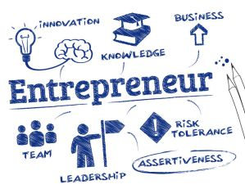
- Positive self-concept: One must have confidence in their personal abilities. Optimism and self-worth often leads to success in any venture.

- Vision: An entrepreneur must think way beyond and discover future opportunities. It is the unique quality of an entrepreneur to foresee both the positive and negative upcomings in the future and not meditate on the successes or failures that have passed;

- Independent thinking: An entrepreneur is someone with an innovative idea. A vital component of their characteristics is independent thinking. It is the entrepreneur’s ability to understand things based on their prior experiences and observations. An underlying virtue of independentthinker is confidence in his/her abilities and an inherent understanding that mistakes are a natural process to coming up with the right solutions.

- Opportunity hunting: A prospective entrepreneur must be able to understand the market they are attempting to enter and more importantly they need to understand what needs to be done to bring their product or service to market. Identification of the right opportunity at the right time often leads to successful ventures. They must haveopportunity-specific knowledge to make full use of prospective opportunities.

- Persistency: An entrepreneur must be self-motivated and energetic to achieve. He needs to ask himself whether he is prepared to work hard, for a very long time, to realize his goals.

- Constant analysis of environment: An entrepreneur must try to examine all the components, internal or external, that may have an influence on the performance of the enterprise. This must be done on a regular basis to determine if the present strategies are enough to achieve the set goals or there is a need to modify them or devise new strategies.

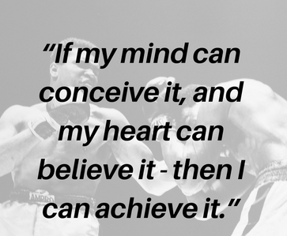
- Learning from failure: Failureis a part and parcel of life. An entrepreneur must be willing to take risks beyond their comfort zone. They should welcome failure as an opportunity to learn and grow. Additionally, willingness to learn constantly irrespective of failure and success is an important criterion for a successful entrepreneur.

- Information seeking: An entrepreneur must always be on the lookout for new developments in their field. Any new information may make or break their venture. Building contacts and utilising information to their advantage is extremely essential for a successful venture.

- Commitment to complete task: Starting a new venture requires extreme dedication and commitment on the part of the owner. It is essential to divide the work into smaller tasks and equally important to complete all the tasks within the stipulated timeline.

- Assertiveness & Resilience: Both these qualities are essential for an entrepreneur if they desire to be successful. Assertiveness refers to an unwavering faith in your ideas and abilities to run a business whereas resilience means showing enough flexibility in decisions and implementation when required.

- Team building: An entrepreneur needs a strong team to accomplish the assignments effectively. The entrepreneur must realize that managing human resources, each with a strong personal belief and a personal objective, is a complex yet rewarding task. Trust, communication, working style and alignment with similar goals of the business/ enterprise are the key factors in building a great team.

- Ethics: An entrepreneur might have to face a lot of ethical choices between ‘right’ and ‘wrong’ during the course of running the enterprise. In such a case, the entrepreneur needs to study proper business guidelines and practices regarding probable contentious issues such as bribery, discrimination, infringement of copy rights, child labour, etc. Following ethical practices helps to provide the fundamental framework for an enterprise to gain public recognition and approval.

- Creativity & Innovation: The ability to produce new and unique ideas is the hallmark of a true entrepreneur. Innovation, on the other hand, is the implementation of that creativity. Be it the introduction of a fresh idea, course of action, resolution or a product, promoting creativity and exploring hitherto new and unknown territories lead to an increase in the productivity of an enterprise. Encouraging the employees to explore new areas and innovative ideas is the means to effective and efficient solution.

Passion and Motivation: Though all the above characteristics are vital for an entrepreneur, the two most importanttraits of a successful entrepreneur are passion for his idea and his work; and a strong motivation to realise that passion. An important hallmark of any entrepreneur is passion. Passion drives an entrepreneur’s actions and helps them surpass different challenges. It gives them the strength to pursue goals in the face of difficulties.
Ask yourself the following:
- What is the one thing that you can work on over and over again without getting bored?
- Name any one thing that keeps you awake at night because you want to finish it.
- Is there anything you have created and you want to continue improving it?
- Is there any one thing you enjoy so much that you want to continue doing it for the rest of your life?
Now think whether you can change this one thing into a business idea.
How? Discuss it in five (5) steps with your partner.
______________________________________________________________________________________________________________________________________________________
To sum up, following are the most important characteristics/ traits of an entrepreneur:
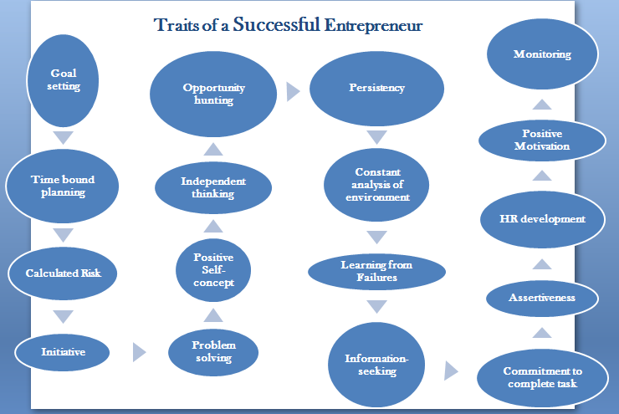
Major Mistakes Entrepreneurs Make
Building a business is not an easy task. As an entrepreneur, you will make a lot of mistakes. It is not a big deal as long as you are ready to learn from your mistakes and try to avoid them in future. Some of the common mistakes made by entrepreneurs include:
- Poor management: Perhaps the most common mistake of entrepreneurs is related to poor business management. Entrepreneurs may not have the ability to drive their own business or may not possess the necessary leadership skills or knowledge required to lead the business. Poor management skills infect an entire organisation; whereas good management skills positively impact a company, for example reduces employee turnover and improves productivity. Poor management skills affect the business after a certain period of operation and especially after it acquires a certain size, which requires management skills.
- Not working on entrepreneurial skills: Always keep striving for improvement in your entrepreneurial skills. Never be satisfied with what you are today. Focus on your flaws and work on them. Take your failures as lessons and try to avoid them in future.
- Lack of financial control: One of the mistakes entrepreneurs make is not managing the finances properly, which can result in insufficient capital and business failure. Financial management requires additional financial control and use of appropriate methods for costing. Having a budget forces us to make thoughtful decisions and establishes fiscal discipline.
- Poor marketing: New entrepreneurs generally think that their product is so revolutionary that they can rely on word of mouth. However, in reality new entrepreneurs will need to heavily invest in marketing to compete and differentiate their products from those of competitors. No matter how great your product is, you will not get the desired results if you don’t invest in marketing.
- Lack of planning: Whether for lack of time or eitherfrom ignorance, entrepreneurs often start business without adequate planning and strategy. A business plan helps entrepreneurs understand the market, where they fit in, how they compete, etc. New businesses may fail because owners don’t put efforts on formulating a business plan or strategy which is meant to keep them from making fatal mistakes.
- Bad inventory: Inventory is among the more significant sources of revenue for a company. After all, inventory equals profit, so an accurate accounting of product in stock and inventory to be ordered can have a dramatic financial impact on your business. In fact, bad inventory can lead to redundant stocks and unjustified expenses and can have a damaging effect on your organization.
- Setting incorrect price: Setting the price of the product or service incorrectly or too much under the influence of prices of competitors or too less from the perception of ‘selling the best product at lowest price’ is one of the mistakes that can lead to business failure.
- Inability to manage growth:The typical challenges that entrepreneurs face are related to development, design, and scaling of their product for increasing the customer base. A well-planned strategy for growth can increase opportunities. Also, know your boundaries. It is not necessary that you know everything. That is why organisations hire a team as each individual has his own strength and weakness. As you grow the business, you will need to expand your workforce and product feature set.

Activities and Exercises
Activity 1.1
Make a team of three-five members and carry out the below given activity.
- List out the skill sets you have for becoming an entrepreneur. Mention any relevant examples for proving the listed qualities.
- List out at least 3 business plans based on your skill sets and resources.
Exercise 1.1
- Who is an entrepreneur and why do you want to be an entrepreneur?
- How will poor finance management affect your business?
- Who is a village-level entrepreneur?

What is Entrepreneurship?
Entrepreneurship is the process of designing, launching and running a new business, which is often initially a small business, and the people who create these businesses are called entrepreneurs. Entrepreneurship has been described as the "capacity and willingness to develop, organize and manage a business venture along with any of its risks in order to make a profit".
Entrepreneurs act as managers and oversee the launch and growth of an enterprise. Entrepreneurship is the process by which either an individual or a team identifies a business opportunity and acquires and deploys the necessary resources required for its exploitation. The exploitation of entrepreneurial opportunities may include:
- Developing a business plan
- Hiring human resources
- Acquiring financial and material resources
- Providing leadership
- Being responsible for both the venture's success or failure
- Risk aversion
While entrepreneurship is often associated with new, small, for-profit start-ups, entrepreneurial behaviour can be seen in small, medium and large-sized firms, new and established firms and in for-profit and not-for-profit organizations, including voluntarysector groups, charitable organizations and the government.
Entrepreneurship may operate within an entrepreneurship ecosystem which often includes:
- Government programmes and services that promote entrepreneurship and support entrepreneurs and start-ups.

- Non-governmental organizations such as small-business associations and organizations that offer advice and mentoring to entrepreneurs (e.g. through entrepreneurship centers or websites)

- Small-business advocacy organizations that lobby governments for increased support for entrepreneurship programmes and more small business-friendly laws and regulations.

- Entrepreneurship resources and facilities (e.g. business incubators and seed accelerators).

- Entrepreneurship education and training programmes offered by schools, colleges and universities.

- Financing (e.g. bank loans, venture capital financing, angel investing and government and private foundation grants).

Factors that Influence Entrepreneurship
Entrepreneurship is influenced by three distinct factors:
- Economic: Economic environment acts as the most immediate stimulus for people to become entrepreneurs as there are no other jobs or opportunities available.

- Social: Social factors can go a long way in encouraging entrepreneurship. In fact it was the highly supportive social environment that made the industrial revolution possible. Social perceptions promote an entrepreneurial behaviour and contribute towards its growth.

- Psychological: People with high aspirations and a need for higher achievement are risk takers and try out new ideas. This stimulates entrepreneurship in them.

Social Entrepreneurship-Concept and Importance
What is Social Entrepreneurship?

Social entrepreneurship is all about recognizing the social problems and achieving a social change by employing entrepreneurial principles, processes and operations. It is all about making a research to completely define a particular social problem and then organizing, creating and managing a social venture to attain the desired change. The change may or may not include a thorough elimination of a social problem. It may be a lifetime process focusing on the improvement of the existing circumstances.

Who is a Social Entrepreneur?

Entrepreneurs are people who venture into new areas primarily with intent of making profit out of the same. Of course, they are socially responsible also and have the obligation of contributing to the well being of the society in which they operate; but this obligation is secondary. However, in social entrepreneurship this obligation of contribution to social well being is primary and in a way profit takes a back seat or is more or less secondary but essential to the survival!

A social entrepreneur is somebody who takes up a pressing social problem and meets it with an innovative or path breaking solution. Since profit making is a secondary objective, therefore they are passionate and determined about what they do. They possess a very high level of motivation and are visionaries who aim at bringing about a change in the way things are.

Moreover, the social entrepreneur targets his/her programmes at the ―“underserved, neglected, or highly disadvantaged population that lacks the financial means or political clout to achieve the transformative benefit on its own.”

Difference between Entrepreneurship and Social Entrepreneurship

The entrepreneur‘s final objective is wealth creation. However, for the social entrepreneur, wealth creation is simply a means to an end. The social entrepreneur participates in profit seeking business ventures to use the profits generated to create valuable social programmes for the whole community.

Case Study

Mr.VergheseKurien: The man behind Operation Flood

This is a story of a young engineer who was born in Calicut and was later known as the Father of the White Revolution or the ‘Milkman of India’.

Honored with some of the most prestigious Government awards like Padma Vibhushan, Ramon Magsaysay and KrushiRatna, Dr Kurien founded AMUL Dairy to stop exploitation of farmers by middlemen.

He breathed his last on December 9, 2012, but he will always be remembered for his immense contribution to the farmers, to theAmul Brand and to the millions of consumers of dairy products.

The year was 1964 when the then Prime Minister Mr.LalBahadurShastri was invited to Anand to inaugurate the new cattle-feed plant of Amul. He was supposed to return back by end of the day but after reaching Anand he insisted on staying there to learn about the success of the co-operatives. He visitedalmost all the co-operatives with Dr. Kurien and was impressed with the process through which Amul was sourcing milk from farmers and at the same time helping them to improve their economic condition.

Later, he returned to Delhi and asked Dr. Kurien to replicate the Amul pattern across the country. The combined effort resulted in creation of the National Dairy Development Board (NDDB) in the year 1965. Dr. Kurien took charge as the chairman of NDDB and began the herculean task of replicating the overall pattern of the working at Anand to other parts of the country. By this time the demand for milk was growing at a faster rate than the supply. India could have easily become the largest importer of milk like Sri Lanka if sufficient steps had not been taken at that time by the Indian government and NDDB.

Money was the biggest problem faced by NDDB during that period and was a critical resource needed to revolutionize the milk industry. To deal with it, NDDB tried to pursue the World Bank for loans and other grants with no conditions at all. When the President of the World Bank came to India in 1969, Dr.Kurien told him – “Give me money and forget about it”. A few days later, World Bank approved the loan for NDDB without even a single condition. This help was part of an operation, later known as Operation Flood – which was done to replicate the Anand working pattern across India.

Operation Flood was subsequently implemented in India in three phases, adding around 0.1 million cooperatives and 5 million milk producers. Dr. Kurien also took several other measures such as developing milk powder, developing several varieties of dairy products, emphasing on the health of cattle and development of vaccines, etc. In 1973, he also set up GCMMF (Gujarat co-operative Milk Marketing Federation) – an individual marketing unit of Amul to sell Amul as a brand in India as well as abroad. He also founded IRMA – Institute of Rural Management Anand in 1979, to pass on the knowledge gained to future generations and to place rural India on the map of India.
As a result of these combined efforts, Amul currently boasts of 15 million milk producers pouring their milk in 1, 44, 246 dairy co-operative societies across the country – a huge chain that has resulted in India being the largest milk producing country today.

Why is there a growing need for Social Entrepreneurs?

In the current economic scenario, financial pressures are aggravating existing social problems such as poverty and unemployment. Social entrepreneurship is essential to lessen the financial impact among the vulnerable sections of society. With pay cuts and job losses happening all over the world, the need of the hour are ideas, innovations, creative solutions and fresh perspectives that can cater to the changing market demands, emerging economies and a new world economic order.

Characteristics of Social Entrepreneurs

- Social Catalysts: Visionaries who create fundamental, social changes by reforming social systems and creating sustainable improvements. According to J. Gregory Dees, ―though they may act locally, their actions have the potential to stimulate global improvements in their chosen arenas, whether that is education, health care, economic development, the environment, the arts, or any other social field.

- Socially impact: Social improvement, as opposed to the creation of profit, should be the ultimate goal of the social entrepreneurs. The success of their endeavours is measured by their social impact, not by the amount of profits generated.

- Opportunity-seeking: Relentless pursuit of their goals, seeing every obstacle as an opportunity to develop and fine-tune their business models.

- Innovative: Creative, willing to think out of box and ready to apply ideas to new situations. They understand that not every innovation will be a success, and they see failures as learning opportunities even as they strive for success.

- Resourceful: Their visions are not limited by the resources that they have. Besides optimizing the use of existing resources, they actively expand their resource pool through collaboration with others.

- Accountable: Social entrepreneurs are accountable to their beneficiaries, and they often ask themselves, ―Am I creating value for the people I am serving? Do I understand their needs?This is because social entrepreneurs want to know how they are actually making an impact. They are also accountable to investors who want to know whether their contributions are indeed stimulating social improvements as promised by the social entrepreneurs.

Examples of Social Entrepreneurs of India:

- VinobaBhave: Founder and leader of the BhudaanAndolan (Land Gift Movement), which led to redistribution of more than 70,00,000 acres of land to aid India‘s untouchables and landless.

- Ela Bhatt: Founded the Self-Employed Women‘s Association (SEWA) in 1972. SEWA is a trade union of poor, unorganised, self-employed women who work as vendors, hawkers and labourers.

- Dr. VergheseKurien: Founder of the AMUL Dairy Project.

- Sharad Vivek Sagar: He is 26-year-old social entrepreneur from Patna, Bihar. He founded Dexterity Global at the age of 16, and has provided opportunities to more than 1.2 million children from remotest areas of the country tro become future leaders.

- Ria Sharma: Initiated a crowd funded organisation ‘Make Love not Scars’, which supports victims of acid attacks in all possible ways. It also urges the victims to show their talents and has created a platform for employment generation for the victims. In 2017, she became the first ever Indian to be awarded the United Nations Goalkeeper Global Award.

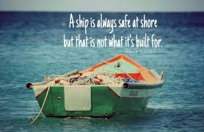
Concept of Risk Taking
Business risk means the possibility of some unfavourable occurrence. According to B. O. Wheeler ― “Risk is the chance of loss. It is the possibility of some adverse occurrence”. There is always a possibility of loss in business even though the businessman exposed to it may not be aware of it.
No Risk No Return
Types of Risk Taking:
Business risks are of a diverse nature and arise due to innumerable factors. These risks can either be insurable or non-insurable. Insurable risks are those which can be covered through different types of insurance policies. The probability of an insurable risk can be determined, in other words such risks can be forecasted.
For example:
(i) Insurable risks are related to life and property against fire, theft, riots etc..Insurance is a contract, represented by a policy, in which an individual or entity receives financial protection or reimbursement against losses from an insurance company. The company pools clients' risks to make payments more affordable for the insured.
Insurance policies are used to protect against the risk of financial losses, both big and small, that may result from damage to the insured or their property, or from liability for damage or injury caused to a third party.
There are a many different types of insurance policies available, and virtually any individual or business can find an insurance company willing to insure them, for a price. The most common types of personal insurance policies are auto, health, homeowners, and life. Businesses require special types of insurance policies that insure against specific types of risks faced by the particular business.
(ii) Non-insurable risks are those whose probability cannot be determined and which cannot be insured against.For example: Fluctuations in price and demand.
These risks may be broadly classified into two types, depending upon their place of origin.
1. Internal Risks
Internal Risks are those risks which arise from the events taking place within the business enterprise. Such risks arise during the ordinary course of a business. These risks can be forecasted and the probability of their occurrence can be determined. Hence, they can be controlled by the entrepreneur to an appreciable extent.
The various internal factors giving rise to such risks are:-
- Human factors are an important cause. They may result from strikes and lock-outs by trade unions; negligence and dishonesty of an employee; accidents or deaths in the industry; incompetence of the manager or other important people in the organisation, etc. Also, failure of suppliers to supply the materials or goods on time or default in payment by debtors may adversely affect the business enterprise.

- Technological factors are the unforeseen changes in the techniques of production or distribution. They may result in technological obsolescence and other business risks. For example, if there is some technological advancement which results in products of higher quality, then a firm which is using the traditional technique of production might face the risk of losing the market for its inferior productquality.

- Physical factors are the factors which result in loss or damage to the property of the firm. They include the failure of machinery and equipment used in business; fire or theft in the industry; damages during transit of goods, etc. They also include losses to the firm arising from the compensation paid by the firm to the third parties on account of intentional or unintentional damages caused to them.
2. External Risks
External risks arise due to the events occurring outside the business organisation. Such events are generally beyond the control of an entrepreneur. Hence, the resulting risks cannot be forecasted and the probability of their occurrence cannot be determined with accuracy.The various external factors which may give rise to such risks:
- Economic factors are the most important causes of external risks. They result from the changes in the prevailing market conditions. They may be in the form of changes in demand for the product, price fluctuations, changes in tastes and preferences of the consumers and changes in income, output or trade cycles. The conditions like increased competition for the product, inflationary tendency in the economy, rising unemployment as well as the fluctuations in world economy may also adversely affect the business enterprise. Such risks which are caused by changes in the economy are known as 'dynamic risks'. These risks are generally less predictable because they do not appear at regular intervals. Also, such risks may not necessarily result in losses to the firm because they may also contain an element of gain for the firm. For instance, due to market fluctuations, a well-known product of a firm may either lose its demand or may occupy a larger market share.
For example: Black and White TV to Flat screen, High Definition TV.

- Natural factors are the unforeseen natural calamities over which an entrepreneur has very little or no control. They result from events like earthquake, flood, famine, cyclone, lightening, tornado, etc. Such events may cause loss of life and property to the firm or cause damage to goods. For example, the Gujarat earthquake caused irreparable damage not only to the business enterprises, but also adversely affected the whole economy of the State.

- Political factors have an important influence on the functioning of a business, both in the short and long term. They result from political changes in a country like fall or change in the Government, communal violence or riots in the country, civil war as well as hostilities with the neighbouring countries. Besides, changes in Government policies and regulations may also affect the profitability and position of an enterprise. For instance, changes in industrial policy and trade policy, annual announcement of the budget, amendments to various legislations, etc. may enhance or reduce the profits of a business enterprise.
For example: In the year 1977, with the change in the political power of the country there was a change in the policy for MNC’s in the country.

- Change in taste and preference: Tastes change with the change in the dynamics of the world.
For example: Earlier there was a preference to eat most of the time at home and fast food was unknown. But nowadays, there has been an increase in fast food outlets all over the country.

Thus, business risk takes a variety of forms. In order to face such risks successfully, every businessman should understand the nature and causes of these risks as well as the various measures which must be taken in order to minimise them. Risks are present everywhere in our society; an entrepreneur should not the disappointed looking into all these risks. Like a phoenix bird, which rises from its own ashes, every entrepreneur is sure to come out successfully facing all these risks.

Identification of Right Business Opportunities
Many reasons motivate entrepreneurs to pursue their dreams of launching profitable companies. Some reasons are better than others, and some reasons are downright bad.
Before making a decision that is difficult to undo, it's important to ask yourself difficult questions and go through your underlying motivations for starting a business before making the leap. By doing so, you can protect yourself from unnecessary risk.

Reasons to Start Own Business-Be your own Boss
Experienced entrepreneurs know the best business ideas arise out of a genuine need for something meaningful in the marketplace, and they will train themselves to become hyperaware of potentially profitable business ideas within their areas of interest. These reasons to start a business are most likely to lead to success.
1. Opportunity
A new business opportunity, perhaps in the form of an unserved need in the marketplace or a new technical innovation, can be an opportunity worth taking advantage of. Be sure the opportunity is real and you are not exaggerating its value.
2. Valuable Idea
If you have an idea that a sizable number of customers are willing to pay for, you have a good reason to start your own business.
3. You Have a Business Idea You Have Already Validated
If you are sure about your business idea, (due to any reason such as a tested prototype, consumer survey, or any form of evidence from years of working in a corporation) and about its need in the market, you can go forward in starting a venture.
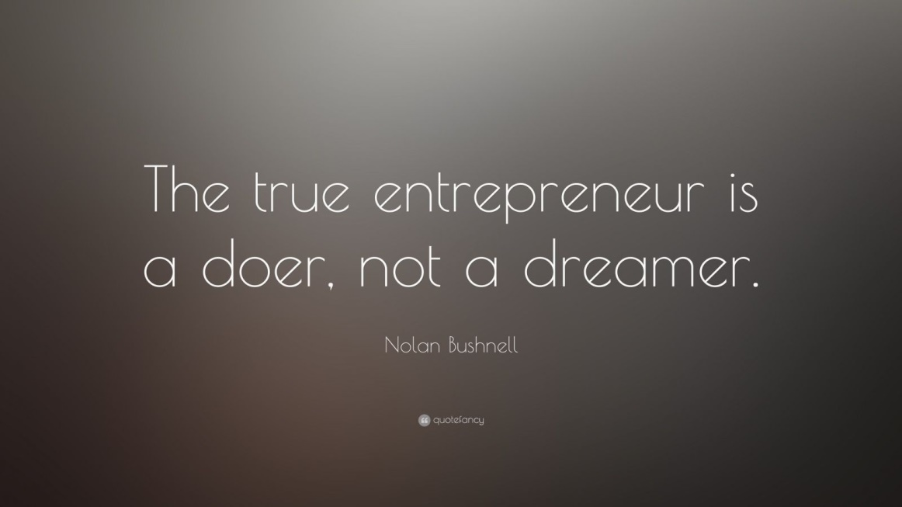
4. You Believe Your Solution Can Achieve Something Unique
If you see an unmet need or an unsolved problem in the market, this is could be your calling. Perhaps no existing competitors address the problem as well as you can, or they only do so partially, leaving room for your superior service or product.
5. You Enjoy Learning by Doing and Taking On New Responsibilities
As you start your own business, you will have to take on a hands-on role in marketing, accounting, sales, operations, human resources, and more. If you like to dive right in, think on your feet, and learn as you go, you have the capacity to do well.
6. Optimism
There will be times when others doubt you and the viability of your idea. That will continue until the signs of your success are visibly apparent. At the beginning, your confidence is essential to keep you working towards our goal.

7. You Won’t Accept Failure
Your progress will initially be slow and uneven. New milestones will be followed by setbacks, and your attitude towards handling these momentary roadblocks will determine your long-term success. If you are the type to get back in the saddle every time you fall down, you are well-suited to be an entrepreneur.

8. Hard Work
Looking at successful entrepreneurs, you rarely find a case where hard work and passion don't go hand in hand. History is full of people who tirelessly pursued their passion and created successful ventures.
9. Experience
You will benefit from having an above average understanding of the industry, markets, customers, and competitive dynamics.These are all things that are difficult to match by industry outsiders, as you'll be able to leverage existing relationships to speed up your progress.
10. Necessary Resources
Having an idea is great, but to start your own business, you need the relevant resources to turn that idea into reality. These resources can come in the form of financial capital, information, technical know-how, or valuable networks that'll help you accelerate your success.
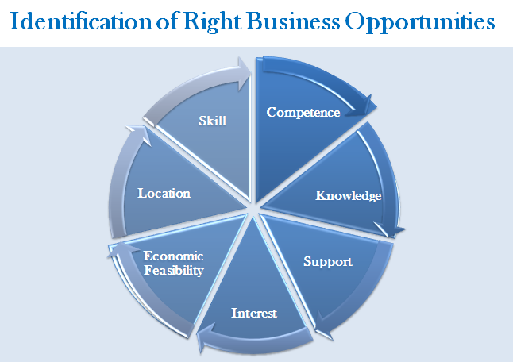

Women Entrepreneurship: Concept and Issues
Gone are the days when women were considered no match for all powerful men in this world. The new generation women across the world have overcome all negative notions and have proved themselves beyond doubt in all spheres of life including the most intricate and cumbersome world of entrepreneurship.
Women have come a long way from just being a homemaker. Some, with little or no background in their chosen entrepreneurship endeavour, have not only managed to overcome knowledge and sector understanding barriers but also showed India how to do business. From making a social impact to being hands-on with technology to opening up new vistas and inspiring their own, these women are the leaders of today.
Women entrepreneurship is the process in which women initiate a business, gather all resources, undertake risks, face challenges, provides employment to others and manages the business independently.
Women entrepreneurship refers to business or organisation started by a woman or group of women. There has been a change in the role of women due to growth in education, urbanization, industrialization and awareness of democratic values.
Women entrepreneurship has been recognised as an important source of economic growth. Women entrepreneurs create new jobs for themselves and others and also provide society with different solutions to management, organisation and business problems. However, they still represent a minority of all entrepreneurs. Women entrepreneurs often face gender-based barriers to starting and growing their businesses, like discriminatory property, matrimonial and inheritance laws and/or cultural practices; lack of access to formal finance mechanisms; limited mobility and access to information and networks, etc.
Women’s entrepreneurship can make a particularly strong contribution to the economic well-being of the family and communities, reduce poverty and propel women’s empowerment, thus contributing to the Millennium Development Goals (MDGs). Thus, governments across the world as well as various developmental organizations are actively undertaking promotion of women entrepreneurs through various schemes, incentives and promotional measures.
Women entrepreneurs in the four southern states and Maharashtra account for over 50% of all women-led small-scale industrial units in India.
Work Life Balance
Work–life balance refers to the balance that a person needs between professional and personal commitments especially with respect to the time allocated for both work and leisure. Work life balance is significant for every working individual, but more so for women as they have to manage their traditional role of home maker along with professional responsibilities.

Causes of work-life imbalance
The major factors for imbalance in work and life could be described as average time spent at work, respective family characteristics and gender identity.
- When an individual spends long hours at work due to overtime, rigid work hours and inflexibility in work requirements, it may lead to an imbalance between work and family duties.
- Different kinds of families require different kinds of efforts on the part of working individuals. This may lead to reduced family satisfaction due to diverse family duties or requirements.
- Gender differences may also lead to a work-life imbalance because of distinct perception of role identity among men and women. It has been observed that men mostly prioritize their work commitments over their family duties in order to provide financial support to their families, whereas women mostly prioritize their family life over work duties.
Although work–life conflict is not gender-specific, men and women may deal with it in different ways. This is mainly due to perceived gender roles and prevalent social norms in a particular society.

Changes in perceived gender roles
Though more and more women are increasingly represented in the workforce, they still face challenges balancing work and home life. Nowadays, many women do not want to just stay at home and indulge in housework without having a career. Also, men are usually expected to be the financial supporter of the family unit due to which they may face an unequal opportunity too.
However, with an ever-changing society, flexibility in gender roles is becoming much more perceptible.Men and women may both need to contribute equally to the household duties and may divide the responsibilities amongst themselves. The role of women in Indian society has changed significantly in the past few decades. The gender stereotypes which have been widespread in the society since decades are breaking slowly.
Around half the total (48 percent) of Indian population is women however; their participation in the economic activities is only 25 percent!Women Entrepreneurship has been defined by the Government of India as an enterprise owned and controlled by women having a minimum financial interest of 51 per cent of the capital and wherein at least 51 per cent of the employed workforce is women.
Despite the constraints, there are various reasons why India needs more Women Entrepreneurs and how it can strengthen us economically, socially and culturally. Some of them are listed below:

1. Economic Growth
Inclusion of more women into the workforce leads to economic growth, productivity and stability. It has been observed that women entrepreneurs have more effective organisational, communicational and networking skills than their male counterparts. Also, women tend to be more careful around money thereby reducing the risk of failure of their ventures. Women tend to spend more on their children’s education and health, which should improves productivity and helps future generations as well.

2. Narrowing Gender Gap
Women entrepreneurs, directly or indirectly, motivate other women to start a business. This leads to more job creation for women which helps in reducing the gender gap in the workforce in the long run. It is believed that when women become successful in a field, the next generation of women is more likely to follow in their steps.

3. Safety at Workplace
Studies have shown that women-owned enterprises tend to have better company culture, high values and transparency. As most women have already faced obstructions in maintaining a work-life balance, they are more adept at allowing time flexibility and be more sensitive to issues faced by women employees.
Moreover, women-led organizations are more sensitive to women safety issues. They plan and implement strict anti-harassment policies and guidelines to ensure safety of women.

4. Social Change
Woman entrepreneurship may lead to great social change which would help to make women more self-dependent and stronger financially. This can increase their confidence, self-esteem and overall well-being. Women tend to invest higher amounts of income into the health and education of their children, which in turn helps to build a healthier and educated youth.
In the words of Former President Dr APJ Abdul Kalam, "Empowering women is a prerequisite for creating a good nation, when women are empowered, society with stability is assured. Empowerment of women is essential as their thoughts and their value systems lead to the development of a good family, good society and ultimately a good nation."

Activities and Exercises 1.2
Activities
- Narrate the success story of an entrepreneur known to you. The entrepreneur can be from the neighbourhood or a national figure.
- Discuss with the team members (formed during Activity 1.1) and choose one feasible business idea. Explain the business idea in just one line.
Exercise
- Who is a social entrepreneur and what are his qualities?
- What are internal and external risks for an entrepreneur?
- What are the reasons to start your own business?

